Construction Updates

As you may have noticed we are working on our drainage in between the two buildings. When entering from the playground area we will use the main lower door and the third grade doors in the morning.

I keep saying think what next year will be like when all of the construction is complete. Thank you in advance for being patient with us till the end of the year.

Making Math Connections

Some helpful hints for math…

* Try to show enthusiasm for what your kids are doing in math.
* Ask them each day at dinner or homework time what they studied in math that day. Let them explain the concepts they’re working on, and follow up with questions. For instance, if they’re learning about decimals, you could ask how decimal points are used in money (they separate the parts of a dollar from the whole dollar).
* Then, when your children finish their homework, have them show you how they solved a few problems. As they explain their methods to you, they’ll be reinforcing their own skills and they’ll be proud to be teaching you something.

Important PTO Dates to Remember

10th: Skate Night

11th: Hat Day

14th – 18th: Paper/Supply Wars Contest

15th: PTO Meeting 3:45 p.m.

17th: Pizza Inn Spirit Night 5:00 p.m. – 8:00 p.m.

25th: Friday Sales & Paper/Supply Wars Parties

Patti Bilyard, Principal

Christina Hamm, Lower Assistant Donna Lorenz, Upper Assistant

**HILLDALE ELEMENTARY JANUARY NEWSLETTER**

It is hard to believe it is the beginning of the 2nd semester and a brand new year! I hope 2019 will be a wonderful year for all of you! Your child will be bringing home their report cards or checklists on Thursday, January 10, 2019. If you have any questions or concerns, or if you would like to request a conference, please contact your child’s teacher; they will answer your questions and help you understand how your child is progressing. 2nd semester starts getting a little harder for the students; they begin to work more independently at all grade levels; and they sometimes start getting frustrated. If you are concerned at any time about your child and the progress he or she is making, please call us or come by and we can discuss what all is going on in the classroom.

**\*\*\*Please remember that we will not be in school on Monday, January 21st in observance of Martin Luther King Jr.**

**Also, the tentative date for the 100th Day of School is Wednesday, January 30th\*\*\***



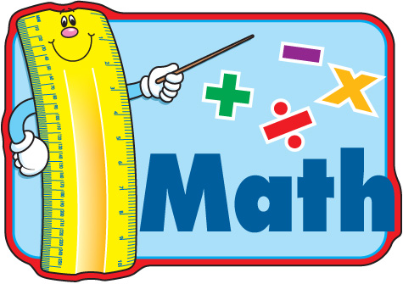

Brrrrrrr!!!! It’s cold out there! Please make sure your child is dressed appropriately when they come to school. Heavy coats, hats and gloves would be fantastic! Again, we will not go outside if the temperature and wind chill combined are below 34 degrees.



